# LIFE SCIENCES P2

# EXEMPLAR 2014

**NATIONAL**

**SENIOR CERTIFICATE**



# GRADE 12

# GRAAD 12

**MARKS: 150**

**TIME: 2½ hours**

**This question paper consists of 14 pages.**

# INSTRUCTIONS AND INFORMATION

|  |  |  |
| --- | --- | --- |
| Read the following instructions carefully before answering the questions. |  |  |

|  |  |  |  |
| --- | --- | --- | --- |
| 1.  2.  3.  4.  5.  6.  7.  8.  9.  10.  11. | Answer ALL the questions.  Write ALL the answers in the ANSWER BOOK.  Start the answers to EACH question at the top of a NEW page.  Number the answers correctly according to the numbering system used in this question paper.  Present your answers according to the instructions of each question.  Do ALL drawings in pencil and label them in blue or black ink.  Draw diagrams or flow charts only when asked to do so.  The diagrams in this question paper are NOT necessarily drawn to scale.  Do NOT use graph paper.  You must use a non-programmable calculator, protractor and a compass, where necessary.  Write neatly and legibly. |  |  |

**SECTION A**

**QUESTION 1**

|  |  |  |  |
| --- | --- | --- | --- |
| 1.1 | Various options are provided as possible answers to the following questions. Choose the correct answer and write only the letter (A to D) next to the question number (1.1.1 to 1.1.10) in the ANSWER BOOK, for example 1.1.11 D. |  |  |

|  |  |  |  |  |
| --- | --- | --- | --- | --- |
|  | 1.1.1 | Which ONE of the following serves as evidence of cultural evolution in early *Homo* species? |  |  |

|  |  |  |  |  |  |
| --- | --- | --- | --- | --- | --- |
|  |  | A  B  C  D | Drawings and carvings on rocks  Animal remains close to a *Homo* skeleton  Male and female skeletons in the same area  More than one *Homo* skeleton in an area |  |  |
|  | 1.1.2 | A father has blood type A. He has 4 children with the following blood types:  Child 1 – A  Child 2 – O  Child 3 – AB  Child 4 – B  What is the blood type of the mother of the above children? | |  |  |
|  |  | A  B  C  D | A  B  O  AB |  |  |

|  |  |  |  |  |
| --- | --- | --- | --- | --- |
|  | 1.1.3 | New alleles arise in a sexually reproducing population through ... |  |  |

|  |  |  |  |  |
| --- | --- | --- | --- | --- |
|  | A  B  C  D | mutations in DNA sequences prior to meiosis.  random fertilisation of gametes during reproduction.  random assortment of homologous chromosomes during meiosis.  exchange of chromatid segments between homologous chromosomes during meiosis. |  |  |

|  |  |  |  |  |  |
| --- | --- | --- | --- | --- | --- |
|  | 1.1.4 | A tall pea plant was crossed repeatedly with a short pea plant. In each of these crosses, they produced only tall offspring. It is reasonable to conclude that the … | |  |  |
|  |  | A  B  C  D | tall pea plant involved in the cross is homozygous.  tall pea plant involved in the cross is heterozygous.  offspring are all heterozygous for height.  short pea plant involved in the cross is heterozygous. |  |  |

|  |  |  |  |  |
| --- | --- | --- | --- | --- |
|  | 1.1.5 | The table below shows a section of the mitochondrial DNA (mtDNA) sequence for a modern human, a chimpanzee and three hominid species. The letter 'X' in the chimpanzee and the hominid sequences means that the DNA base was the same as that found in the modern human sequence. |  |  |

|  |  |
| --- | --- |
| **ORGANISM** | **SECTION OF mtDNA SEQUENCE** |
| Modern human | AAT-TCC-CCG-ACT-GCA-ATT-CAC-CTT |
| Chimpanzee | XXX-XXX-TXA-TTX-XXX-XAC-TGA-AAA |
| Hominid species 1 | GGX-CTT-TTA-TTC-XTC-TCC-GTA-TAG |
| Hominid species 2 | GGX-XGX-XXA-TTC-XTC-CCC-TGT-AAG |
| Hominid species 3 | XTA-XXX-XXA-TTX-ATC-CXC-TGT-TCC |

|  |  |  |  |  |
| --- | --- | --- | --- | --- |
|  |  | From the data in the table above it is possible to conclude that … |  |  |

|  |  |  |  |  |  |
| --- | --- | --- | --- | --- | --- |
|  |  | A  B  C  D | chimpanzees are more closely related to hominid species 3 than they are to modern humans.  hominid species 1 is probably the most recent common ancestor of chimpanzees and modern humans.  modern humans are more closely related to hominid species 2 than to hominid species 3.  modern humans are more closely related to hominid species 3 than to hominid species 2. |  |  |

|  |  |  |  |  |
| --- | --- | --- | --- | --- |
|  | 1.1.6 | The following data represents a small section of a sequence of nucleic acid bases taken from an animal cell:  **A G C U C G U U**  From this data it is reasonable to conclude that … |  |  |

|  |  |  |  |  |  |
| --- | --- | --- | --- | --- | --- |
|  |  | A  B  C  D | this portion of nucleic acid will code for a chain of eight amino acids.  the sequence given will be complementary to the sequence C T C G T G C T T.  the nucleic acid shown contains the sugar ribose.  the nucleic acid shown is DNA. |  |  |

|  |  |  |  |  |
| --- | --- | --- | --- | --- |
|  | 1.1.7 | The list below provides information relating to the replication of DNA:   1. Complementary nucleotides bind to each of the two strands. 2. Sugar phosphate bonds form between the nucleotides. 3. The newly formed DNA molecules are identical to each other. 4. After unwinding, the DNA molecule forms two single strands.   The correct order of these events as they occur in DNA replication is … |  |  |

|  |  |  |  |  |  |
| --- | --- | --- | --- | --- | --- |
|  |  | A  B  C  D | 1, 2, 3 and 4.  1, 2, 3 and 2.  4, 2, 1 and 3.  4, 1, 2 and 3. |  |  |
|  | 1.1.8 | Which ONE of the following accounts for gametes having a single allele only for a particular characteristic, instead of two? | |  |  |
|  |  | A  B  C  D | The chromosome number is halved during Meiosis II  Mendel's principle of segregation  Mendel's principle of independent assortment  The 'law' of dominance |  |  |
|  | 1.1.9 | In multiple alleles … | |  |  |

|  |  |  |  |  |  |
| --- | --- | --- | --- | --- | --- |
|  |  | A  B  C  D | more than one gene controls a trait or characteristic.  there are more than two different alleles for the same gene.  the different alleles for the same characteristic are at different positions.  there are only two alleles for a particular gene. |  |  |

|  |  |  |  |  |
| --- | --- | --- | --- | --- |
|  | 1.1.10 | In a situation where a characteristic is expressed more frequently in males than in females in humans, we can conclude that … |  |  |

|  |  |  |  |  |  |
| --- | --- | --- | --- | --- | --- |
|  |  | A  B  C  D | one allele is dominant over the other.  the alleles for the characteristic are located on the X chromosomes.  the alleles for the characteristic are located on the autosomes.  the alleles for the characteristic are located on the Y chromosomes. (10 x 2) |  | **(20)** |

|  |  |  |  |
| --- | --- | --- | --- |
| 1.2 | Give the correct biological term for each of the following descriptions. Write only the term next to the question number (1.2.1 to 1.2.6) in the ANSWER BOOK. |  |  |

|  |  |  |  |  |
| --- | --- | --- | --- | --- |
|  | 1.2.1  1.2.2  1.2.3  1.2.4  1.2.5  1.2.6 | An allele that does not influence the phenotype when found in the heterozygous condition  The position of a gene on a chromosome  The physical and functional expression of a gene  Chromosomes that are not responsible for sex determination  The process of finding a desirable gene, isolating it and then moving it into the cells of another organism  The two parts of a chromosome held together by a centromere  (6 x 1) |  | **(6)** |

|  |  |  |  |
| --- | --- | --- | --- |
| 1.3 | Indicate whether each of the statements in COLUMN I applies to **A only**, **B only**, **both A and B** or **none** of the items in COLUMN II. Write **A only**, **B only**, **both A and B**, or **none** next to the question number (1.3.1 to 1.3.8) in the ANSWER BOOK. |  |  |

|  |  |  |  |  |  |
| --- | --- | --- | --- | --- | --- |
| **COLUMN I** | | **COLUMN II** | |  |  |
| 1.3.1 | Discovered the double helical structure of DNA | A  B | Francis Crick  James Watson |  |  |
| 1.3.2 | Describes evolution as consisting of long phases of little change alternating with short phases of rapid change | A  B | punctuated equilibrium  Darwinism |  |  |
| 1.3.3 | Variation within a population in which there is a range of intermediate phenotypes | A  B | discontinuous variation  continuous variation |  |  |
| 1.3.4 | Evidence for evolution | A  B | mitochondrial DNA  cladogram |  |  |
| 1.3.5 | Chromosome condition of a cell that has a single set of chromosomes | A  B | diploid  haploid |  |  |
| 1.3.6 | Two alleles of a gene that are equally dominant | A  B | codominance  complete dominance |  |  |
| 1.3.7 | The full complement of genes present in an organism | A  B | karyotype  phenotype |  |  |
| 1.3.8 | Bonds that hold amino acids together in a protein molecule | A  B | hydrogen bonds  peptide bonds |  |  |
|  |  |  | (8 x 2) |  | **(16)** |

|  |  |  |  |
| --- | --- | --- | --- |
| 1.4 | In pea plants the allele for round seeds (R) is dominant over the allele for wrinkled seeds (r). The allele for yellow seeds (Y) is dominant over the allele for green seeds (y).  Plant A, heterozygous for both seed shape and seed colour, was crossed with plant B, which had wrinkled, green seeds. |  |  |

|  |  |  |  |  |
| --- | --- | --- | --- | --- |
|  | 1.4.1  1.4.2  1.4.3  1.4.4 | Write down the genotype of:  (a) Plant A  (b) Plant B  Write down ALL the possible genotypes of the gametes of plant A.  State the phenotype of an offspring having the genotype:  (a) rrYy  (b) RrYy  When plant B was crossed with plant C, all the offspring had round yellow seeds.  Use this information and write down the genotype of plant C. |  | (1)  (1)  (2)  (1)  (1)  (2)  **(8)** |

|  |  |  |  |
| --- | --- | --- | --- |
|  | **TOTAL SECTION A:** |  | **50** |

**SECTION B**

|  |  |  |
| --- | --- | --- |
| **QUESTION 2** |  |  |

|  |  |  |  |
| --- | --- | --- | --- |
| 2.1 | The diagram below shows the process of protein synthesis. |  |  |

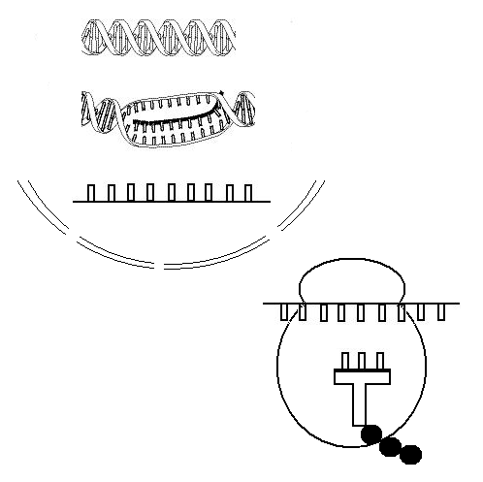

**X**

**A U G C C A A G A**

**Y**

**Z**

**Process V**

**Process W**

**1 2 3**

**S**

**A U G C C A A G A**

|  |  |  |  |  |
| --- | --- | --- | --- | --- |
|  | 2.1.1 | Identify the following: |  |  |

|  |  |  |  |  |  |  |  |
| --- | --- | --- | --- | --- | --- | --- | --- |
|  |  | | (a)  (b) | | Molecule **X**  Organelle **Y** |  | (1)  (1) |
|  | | 2.1.2 | | Identify the nitrogenous base labelled: | |  |  |

|  |  |  |  |  |  |
| --- | --- | --- | --- | --- | --- |
|  |  | (a)  (b) | 1  3 |  | (1)  (1) |

|  |  |  |  |  |
| --- | --- | --- | --- | --- |
|  | 2.1.3  2.1.4 | Describe the role of DNA during transcription.  Describe the part of protein synthesis shown as process **W**,which occurs at organelle **Y**. |  | (3)  (4) |

|  |  |  |  |  |
| --- | --- | --- | --- | --- |
|  | 2.1.5 | The table below shows the amino acids that correspond with different DNA codes. |  |  |

|  |  |
| --- | --- |
|  |  |
| **AMINO ACID** | **DNA CODE** |
| Arginine | TCT |
| Methionine | TAC |
| Glycine | GGT |
|  |  |

|  |  |  |  |  |
| --- | --- | --- | --- | --- |
|  |  | Write down the correct sequence of amino acids coded for by structure **S** in the diagram on the previous page. |  | (3) **(14)** |

|  |  |  |  |
| --- | --- | --- | --- |
| 2.2 | The phylogenetic tree below shows one interpretation of the origin of humans. The dotted lines indicate the possible evolutionary relationships, and the vertical bars show the period during which the organisms are believed to have existed on earth. |  |  |

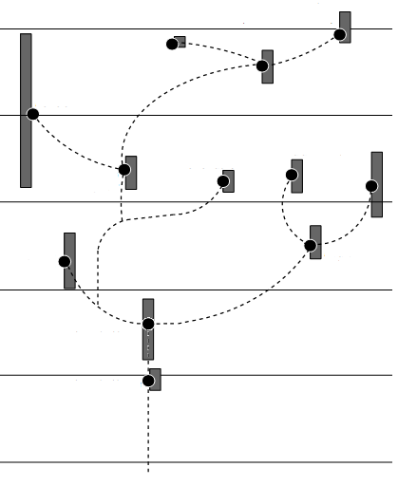

*Homo sapiens*

*Homo*

*neanderthalensis*

*Homo*

*habilis*

*Paranthropus*

*boisei*

*Homo heidelbergensis*

*Paranthropus*

*robustus*

*Homo*

*ergaster*

*Homo*

*erectus*

*Paranthropus*

*aethiopicus*

*Australopithecus*

*africanus*

*Australopithecus*

*afarensis*

*Australopithecus*

*anamensis*

**Present**

**1 MYA**

**2 MYA**

**3 MYA**

**4 MYA**

**5 MYA**

**KEY:**

**MYA = Million Years Ago**

|  |  |  |  |  |
| --- | --- | --- | --- | --- |
|  | 2.2.1  2.2.2 | Use the diagram to identify ONE organism that may have competed with *Homo heidelbergensis* for resources.  Identify the common ancestor that gave rise to both *Paranthropus* and *Homo*. |  | (1)  (1) |

|  |  |  |  |  |  |
| --- | --- | --- | --- | --- | --- |
|  | 2.2.3 | (a)  (b) | For what period of time did *A*. *africanus* exist on Earth? Show all working.  Name ONE piece of evidence that could be used to prove that *A*. *africanus* existed during the time period calculated in QUESTION 2.2.3(a). |  | (3)  (1) |

|  |  |  |  |  |  |  |
| --- | --- | --- | --- | --- | --- | --- |
|  | 2.2.4 | (a)  (b) | Which organism, *H*. *ergaster* or *H*. *neanderthalensis*, is more closely related to modern-day humans?  Explain your answer to QUESTION 2.2.4(a) using information in the diagram. |  | (1)  (2) | |
|  |  | | |  | | **(9)** |

|  |  |  |  |
| --- | --- | --- | --- |
| 2.3 | The diagram below shows the result of abnormal meiosis, starting with a cell showing chromosome pair 21. |  |  |

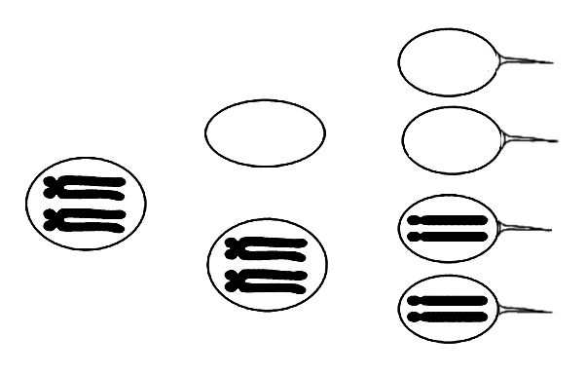

Sperm R

Sperm S

Sperm T

Sperm U

|  |  |  |  |  |
| --- | --- | --- | --- | --- |
|  | 2.3.1  2.3.2  2.3.3  2.3.4 | Explain the number of chromosomes present in sperm **R** and sperm **T**.  How many copies of chromosome 21 would you expect in a normal gamete?  What genetic disorder will result if sperm **U** fertilises a normal ovum?  Describe TWO ways in which meiosis contributes to genetic variation. |  | (3)  (1)  (1)  (7)  **(12)** |

|  |  |  |  |
| --- | --- | --- | --- |
| 2.4 | Study the diagrams below showing structures of different organisms. |  |  |

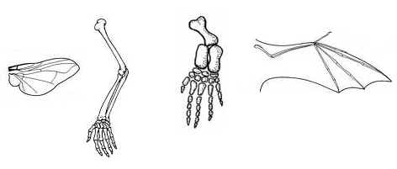

Human limb

Butterfly wing

Bat wing

**Diagram 2**

**Diagram 3**

**Diagram 4**

Whale limb

**Diagram 1**

|  |  |  |  |  |
| --- | --- | --- | --- | --- |
|  | 2.4.1  2.4.2 | Which diagram represents a structure that is analogous to the structure in Diagram 4?  Write down the numbers of any TWO diagrams that represent homologous structures. |  | (1)  (2) |

|  |  |  |  |  |
| --- | --- | --- | --- | --- |
|  | 2.4.3 | What information do analogous and homologous structures provide about evolution? |  | (2)  **(5)**  **[40]** |

|  |  |  |
| --- | --- | --- |
| **QUESTION 3** |  |  |

|  |  |  |  |
| --- | --- | --- | --- |
| 3.1 | Scientists investigated the resistance of mosquitos to DDT.  The following steps were followed:   * They captured a sample of mosquitos from the environment. * The mosquitos were then exposed to a standard dose of DDT (4% DDT for 1 hour) in the laboratory. * The number of mosquitos that died was counted. * Those that survived were left to reproduce. * A sample was taken from this population every two months and the same procedure was followed for a period of 16 months.   The results are shown in the table below. |  |  |

|  |  |
| --- | --- |
| **TIME**  **(IN MONTHS)** | **MORTALITY OF MOSQUITOES (%)** |
| 0 | 95 |
| 2 | 87 |
| 4 | 80 |
| 6 | 69 |
| 8 | 60 |
| 10 | 54 |
| 12 | 35 |
| 14 | 27 |
| 16 | 22 |

|  |  |  |  |  |
| --- | --- | --- | --- | --- |
|  | 3.1.1  3.1.2  3.1.3  3.1.4  3.1.5  3.1.6 | Identify the:   1. Independent variable 2. Dependent variable   Formulate a hypothesis for this investigation.  Draw a line graph to show how the mortality of mosquitoes changed over the period of the investigation due to the application of DDT.  State TWO factors, other than those mentioned, that should be controlled in this investigation.  State TWO ways in which the scientists could improve the reliability of their results.  Explain, in terms of natural selection, how mosquitoes may develop resistance to DDT. |  | (1)  (1)  (3)  (6)  (2)  (2)  (8)  **(23)** |

|  |  |  |  |
| --- | --- | --- | --- |
| 3.2 | Study the table below, which indicates some of the hominid fossils found in different parts of the world. |  |  |

|  |  |  |
| --- | --- | --- |
| **SPECIES** | **AREA WHERE IT WAS FOUND** | **PERIOD OF EXISTENCE** |
| *Australopithecus afarensis* | Eastern Africa | 3,4–2,8 mya |
| *Australopithecus africanus* | Southern Africa | 2,1–2,8 mya |
| *Australopithecus sediba* | Southern Africa | 2,0–1,9 mya |
| *Homo habilis* | Sub-Saharan (Africa) | 2,3–1,4 mya |
| *Homo erectus* | Africa, Europe, Asia | 1,5–0,2 mya |
| *Homo heidelbergensis* | Europe, China | 0,6–0,35 mya |
| *Homo neanderthalensis* | Europe, Western Asia | 0,35–0,03 mya |
| *Homo sapiens* | Worldwide | 0,2 mya–present |

[Adapted from *The Evolutionary Road*, Jamie Shreeve, *National Geographic*, July 2010]

|  |  |  |  |  |
| --- | --- | --- | --- | --- |
|  | 3.2.1  3.2.2 | Explain why the information in the table supports the 'Out of Africa' hypothesis.  Describe how the analysis of mitochondrial DNA is used to support the 'Out of Africa' hypothesis. |  | (2)    (3)  **(5)** |

|  |  |  |
| --- | --- | --- |
|  | 3.3 | The pedigree diagram below shows the inheritance of Daltonism in a family. Daltonism (red-green colour-blindness) is sex-linked. The allele for Daltonism is recessive to the allele for normal colour vision. |

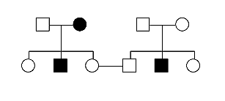

**KEY:**

Normal male

Colour-blind male

Normal female

Colour-blind female

**1**

**2**

**3**

**4**

**5**

**6**

|  |  |  |  |  |
| --- | --- | --- | --- | --- |
|  | 3.3.1 | Use the symbols XD, Xd and Y to state the genotype of the following: |  |  |

|  |  |  |  |  |  |
| --- | --- | --- | --- | --- | --- |
|  |  | (a)  (b) | Individual **2**  Individual **3** |  | (2)  (2) |

|  |  |  |  |  |
| --- | --- | --- | --- | --- |
|  | 3.3.2  3.3.3 | How many family members not affected by Daltonism are definitely carriers?  Use a genetic cross to determine the possible genotypes and phenotypes of the offspring that may be formed by individuals **5** and **6**. |  | (2)  (6)  **(12)** |
|  | **TOTAL SECTION B:** | |  | **[40]**  **80** |

|  |  |  |
| --- | --- | --- |
| **SECTION C**  **QUESTION 4** |  |  |

|  |  |  |
| --- | --- | --- |
| It is thought that modern humans evolved gradually from ape-like beings over millions of years through speciation.  Describe how a single species can form new species, and explain how the differences in the skulls and other parts of the skeleton of primitive ape-like beings and modern humans support the idea that the general trend in human evolution has been towards bipedalism and a change in diet from raw food to cooked food.  Content:  Synthesis: |  | (17)  (3)  **(20)** |

|  |  |  |  |
| --- | --- | --- | --- |
| **NOTE:** | NO marks will be awarded for answers in the form of flow charts or diagrams. |  |  |

|  |  |  |  |
| --- | --- | --- | --- |
|  | **TOTAL SECTION C:**  **GRAND TOTAL:** |  | **20**  **150** |